Extents Base Class

**Base Class**  
read Properties, Web Driver Initialization, Before Suite and After Suite

**Action Driver**

Navigation  
Click  
Type  
Scroll  
Select  
Wait

**Utility Component**

Screenshot Util  
Extent class  
Log file  
Listeners  
Data Providers

**Config files**

POM.xml  
extent-config.xml  
log4j.xml  
config.properties  
testng.xml

**Folders**

Test Data  
Screenshots  
Drivers  
Logs  
Reports

**Object Repository**

Home Page  
Login Page  
Register Page  
Add to cart Page Order Page  
Payment Page

**Test Cases/Scripts**  
LoginPageTest, RegisterPageTest, AddtocartTest, PaymentTest, OrderpageTest

Extends

Base Class

TestNG.XML

POM.XML

Git and Github

Jenkins CI Tool

Development

Phase

Execution Phase

CI

**Key Components in this Framework**

* Config.Properties file for Constants
* Extent Report and PDF Report
* TestNG with Groups and Priorities
* Simplified script writing
* Cross Browser Testing
* New Selenium Customized functions
* Maven for Jar files version control
* Created dependencies for Jar files using Maven
* Git configuration
* Jenkins Integration
* Ready to use Frame work

**Selenium Framework Integration**

**Maven:** Using Maven for build, execution and dependency purpose. Integrating the TestNG dependency in POM.xml file and running this POM.xml file using Jenkins.

**Version Control Tool:** We use Git as a repository to store our test scripts.

**Jenkins:** By using Jenkins CI (Continuous Integration) Tool, we execute test cases on daily basis and also for nightly execution based on the schedule. Test Result will be sent to the peers using Jenkins.

**Reports**

Failed Test Cases Report  
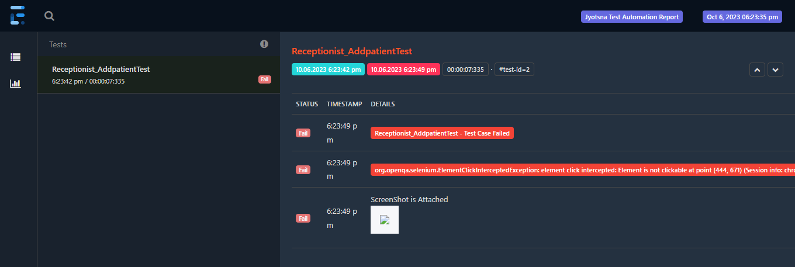

Passed Test Cases Report

